Circle Language Spec: Events

Explicit Interface of Event Object
The previous article showed how the implementation of an event object explicitly looks. The interface of an Event object, so the part that other objects interact with, looks as follows:

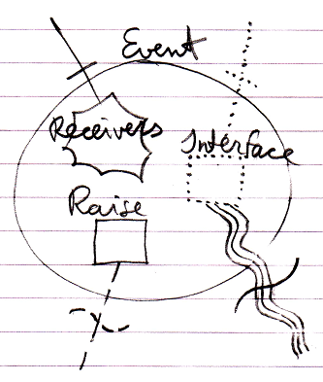

The connectors at the top of the picture are the members that the event receiver will interact with: it will register its command as a Receiver and it will implement the command Interface.

The connectors at the bottom of the picture are the members that the event sender will interact with: it will call the Raise command of the event and it will also define the data that will form the command Interface of the event.

